**VISVESVARAYA TECHNOLOGICAL UNIVERSITY**

**BELAGAVI, KARNATAKA-590018**



A Mini Project Report on

**“ONLINE ART GALLERY MANEGEMENT”**

*Submitted in partial fulfillment towards Mini Project* *Work of V semester of*

**Bachelor of Engineering**

In

**Computer Science and Engineering**

Submitted by

**Prakruthi S 4GW16CS415**

**R Amruthavarshini 4GW16CS416**

Under the Guidance of

**Ravi Kumar V G**

**Assistant Professor**



**DEPARTMENT OF COMPUTER SCIENCE AND ENGINEERING**

**GSSS INSTITUTE OF ENGINEERING & TECHNOLOGY FOR WOMEN**

(Affiliated to VTU, Belagavi, Approved by AICTE, New Delhi & Govt. of Karnataka)

**K.R.S ROAD, METAGALLI, MYSURU-570016**

**2017-18**

*Geetha Shishu Shikshana Sangha (R )*

**GSSS INSTITUTE OF ENGINEERING & TECHNOLOGY FOR WOMEN**

(Affiliated to VTU, Belagavi, Approved by AICTE, New Delhi & Govt. of Karnataka)

K.R.S Road, Mysuru, Karnataka-570016

**DEPARTMENT OF COMPUTER SCIENCE AND ENGINEERING**



**2016-17**

**CERTIFICATE**

Certified that the Mini-Project titled **“ONLINE ART GALLERY”** is a bonafide work carried out by **R Amruthavarshini (4GW16C416)** in the partial fulfillment towards Seminar of V semester of **Bachelor of Engineering** in **Computer Science and Engineering** of the Visvesvaraya Technological University, Belagavi, during the year 2016-2017. The report has been approved as it satisfies the academic requirements.

**Signature of the Guide Signature of the HOD**

**(Mr. Ravi Kumar V G) (Dr. S Meenakshi Sundaram)**

Assistant Professor Professor and Head

Dept. of CS&E Dept. of CS&E

GSSSIETW, Mysuru GSSSIETW, Mysuru

**ACKNOWLEDGEMENT**

First and foremost we offer our sincere thanks to Smt. Vanaja B Pandit, Honorary Secretary, GSSSIETW and the management of GSSSIETW, Mysuru for providing help and support to carry out the project.

We would like to express our gratitude to our Dean (Academics), Dr. Shivakumar M, for providing us a congenial environment for engineering studies and also for having showed us the way to execute the project.

We express our heart filled thanks to, Dr. S Meenakshi Sundaram , Professor and Head, Department of Computer Science and Engineering, GSSSIETW, Mysuru whose guidance and support goes beyond words.

We whole heartedly thank our Guide, Sri. Ravi Kumar V G, Assistant Professor, Department of Computer Science and Engineering, GSSSIETW, Mysuru for having shared a genuine desire to make a positive contribution to address the challenges associated with every element of the project.

We gratefully acknowledge the help & cooperation offered by all the teaching and non-teaching staff members of Department of Computer Science and Engineering, GSSSIETW, Mysuru.

**Prakruthi S**

**R Amruthavarshini**

## 

**CONTENTS**

Acknowledgement i

Abstract ii

Contents iii

List of Figures iv

List of Tables v

1. **INTRODUCTION 1**
   1. Overview of the project
   2. Aim of the project.
2. **REQUIREMENT SPECIFICATION**
   1. Software requirements and hardware requirements
      1. Software requirements
      2. Hardware requirements
3. **DESIGN**
   1. ER Diagram
   2. Schema Diagram
4. **IMPLEMENTATION**
   1. Pseudo code
5. **SNAPSHOTS**

**CONCLUSION**

**REFERENCES**

**ABSTRACT**

The purpose of Online Art Gallery is to automate the existing manual system by the help of computerized equipments and full-fledged computer software, fulfilling their requirements, so that their valuable data/information can be stored for a longer period with accessing and manipulation of the same. The required software and hardware are easily available and easy to work with.

Online Art Gallery, as described above, can, lead to error free, secure, reliable and fast management system. It can assist the user to concentrate on their other activities rather to concentrate on the record keeping. Thus it will help organization in better utilization of resources. The organization can maintain computerized records without redundant entries. That means that one need not be distracted by information that is not relevant, while being able to reach the information.

The aim is to automate its existing manual system by the help of computerized equipments and full-fledged compute software, fulfilling their requirements ,so that their valuable data/information can be stored for a longer period with easy accessing and manipulation of the same. Basically the project describes how to manage for good performance and better services for the clients.

**LIST OF FIGURES**

|  |  |  |
| --- | --- | --- |
| **FIGURE NO** | **DESCRIPTION** | **PAGE NO**. |
| 1 | Home page screen |  |
| 2 | All arts screen |  |
| 3 | Arts details Screen |  |
| 4 | Order details screen |  |
| 5 | Customer login screen |  |

**1. INTRODUCTION**

The “Online Art Gallery” has been developed to over the problems prevailing in the practicing manual system. This software is supported to eliminate and in some cases reduce the hardships faced by this existing system.

The application is reduced as much as possible to avoid errors while entering the data .it also provides error message while entering invalid data. No formal knowledge is needed for the user to use this system. Thus by this all it proves it’s is user friendly. Online Art Gallery, as described above, can lead to error free, secure, reliable and fast management system. It can assist user to concentrate on the record keeping.

Every organization, whether big or small, has challenges to overcome and managing the information of order, arts, customer, art gallery, stock.Every Online Art Gallery has different arts needs, therefore we design exclusive employee management systems that are adapted to your managerial requriments.This is designed to assist in stargic planning and will help you ensure that your organization is equipped with the right level of information and details for your future goals.

1.1 OVERVIEW OF ONLINE ART GALLERY

The project on Online Art Gallery is to manage the details of Arts, Order, Order Update, Customer; Stock .It manages all the information about Arts, Art Gallery, and Stock Arts. The project is totally built at the administrative end and thus only the administrator is guaranteed the access. The purpose of the project is to build an application program to reduce the manual work for managing the data

It may help collecting perfect management in details. In very short time, the collection will be obvious, simple and sensible. It will help a person to know the management of passed year perfectly and vividly. It also helps in current all works relative to Online Art Gallery. This project contains a lot of advance modules which makes the back end system very powerful. In current system, we have integrated single payment system cash on delivery but in future we will enhance it with online payment system.

1.2 AIM OF THE PROJECT

Our project aims at Business process automation, i.e. we have tried to computerize various processes of Online Art Gallery.

* In computer system the person has to fill the various forms & number of copies of the forms can be easily generated at the time.
* In computer system, it is not necessary to create the manifest but we can directly print it, which saves our time.
* To assist the staff in capturing the effort spent on their respective working areas.
* To utilize resources in an efficient manner by increasing their productivity through automation.
* The system generates types of information that can be used for various purposes.
* It satisfies the user requirements.
* Be easy to understand by the user and the operator.
* Be easy to operate.
* Have a good user interface
* Be expandable.
* Delivered on schedule within the budget.

**2. REQUIREMENTS SPECIFICATION**

**2.1.1 SOFTWARE REQUIREMENTS**

|  |  |  |
| --- | --- | --- |
| **Name of the component** | **Specifications** | |
| Operating System | Windows98,Windows XP,Windows7,Linux | |
| Language | ASP.NET | |
| Database | My SQL server | |
| Browser | Any of Mozilla,Opera,Chrome | |
| Web Server | IIS web server | |
| Software Development Kit | Microsoft Windows SDK | |
| Scripting language Enable | | VB.NET |
| Database JDBC Driver | | MySQL Jconnector |

**2.1.2 HARDWARE REQUIREMENTS**

|  |  |
| --- | --- |
| **NAME OF THE COMPONENT** | **Specification** |
| Processor | Pentium 111 630Mhz |
| RAM | 128 MB |
| Hard disk | 20 GB |
| Monitor | 15”color monitor |
| Keyboard | 122 keys |

**3. DESIGN**

**3.1 ER DIAGRAM**

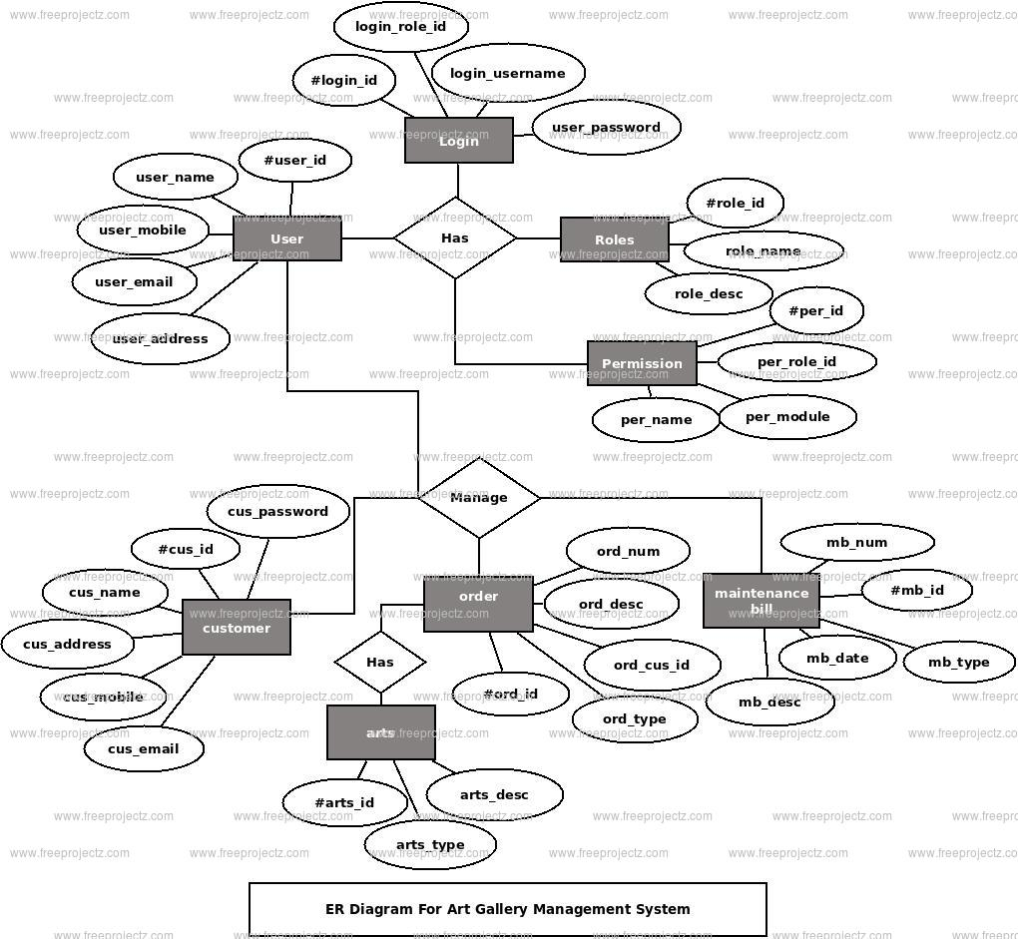

**3.2 SCHEMA DIAGRAM**

**Arts**

|  |  |  |
| --- | --- | --- |
| Arts_id | Arts_ title | Arts _description |

**Customer**

|  |  |  |  |  |
| --- | --- | --- | --- | --- |
| Cust_id | Cust_name | Cust_mobile | Cust_email | |
| Cust_address | Cust_password |

**Order**

|  |  |  |  |
| --- | --- | --- | --- |
| Order_id | Order_cust_id | Order_no | Order_description |

**Order update**

|  |  |
| --- | --- |
| Order_update_id | Order_update_description |

**Payment**

|  |  |  |  |
| --- | --- | --- | --- |
| Payment_id | Payment_cust_id | Payment_date | Payment_bill |
| Payment_type | Payment_description |

**Arts _stock**

|  |  |  |  |
| --- | --- | --- | --- |
| Stock_id | Stock_items | Stock_no | **Stock_description** |

**4. IMPLEMENTATION**

**4.1 PSEUDOCODE**

body class="bg agileinfo">

<form id="form1" runat="server">

<h1 class="agile_head text-center">Art Museum</h1**>**

<div class="w3layouts_main wrap">

<!--Horizontal Tab-->

<div id="parentHorizontalTab_agile">

<ul class="resp-tabs-list hor_1">

<li>Admin LogIn</li>

<li>User Registration</li>

<li>User LogIn</li>

</ul>

<div class="resp-tabs-container hor_1">

<div class="w3_agile_login">

<div class="agile_form">

<p>User Name</p>

<asp:TextBox CssClass="mytextbox" ID="Txtauname"

runat="server"></asp:TextBox>

<p>Password</p>

<asp:TextBox TextMode="Password" ID="Txtapass"

runat="server"></asp:TextBox>

<asp:Button UseSubmitBehavior="true" class="agileinfo" ID="Btnalog" OnClick="Btnalog_Click" runat="server" Text="LogIn" />

</div>

/div><div class="agile_its_registration">

<div class="agile_form">

<p>Username</p>

<asp:TextBox CssClass="mytextbox" ID="Txtreguname"

runat="server"></asp:TextBox>

<p>Email</p>

<asp:TextBox TextMode="Email" ID="Txtemail"

runat="server"></asp:TextBox>

<p>Phone</p>

<asp:TextBox ID="Txtregphone" runat="server"></asp:TextBox>

<p>Password</p>

<asp:TextBox TextMode="Password" ID="Txtregpass"

runat="server"></asp:TextBox>

<asp:Button class="agileinfo" ID="btnreg" runat="server"

OnClick="btnreg_Click" Text="SignUp" />

<asp:Button class="agileinfo" ID="Btnreset"

OnClick="Btnreset_Click" runat="server" Text="Reset" />

</div>

</div>

<div class="agile_its_registration">

<div class="agile_form">

<p>Email</p>

<asp:TextBox TextMode="Email" ID="Txtulogmail"

runat="server"></asp:TextBox>

<p>Password</p>

<asp:TextBox TextMode="Password" ID="Txtuloginpass"

runat="server"></asp:TextBox>

<asp:Button class="agileinfo" ID="Btnulgn

" runat="server" OnClick="Btnulgn_Click" Text="Login" />

</div>

</div>

</div>

</div> <!-- //Horizontal Tab -->

</div>

<div class="agileits_w3layouts_copyright text-center">

<p>Art Museum</p> </div>

<!--tabs-->

</form>

**5. SNAPSHOTS**

**1. HOME PAGE SCREEN**

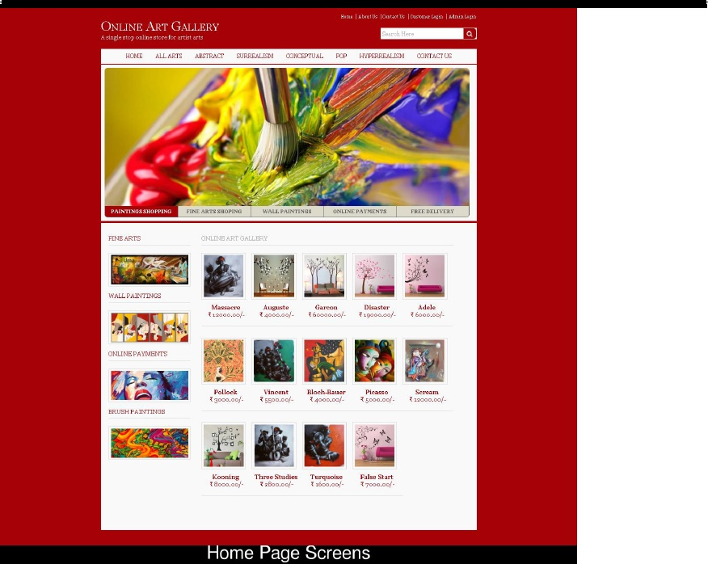

**2. ALL ARTS SCREEN**

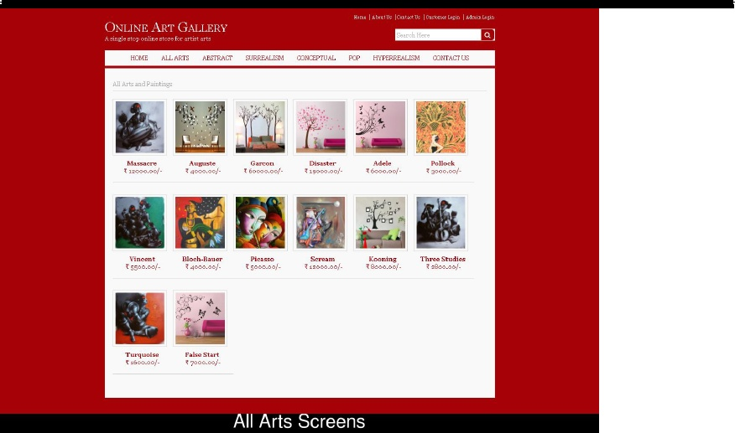

**3. ARTS DETALIS SCREEN**

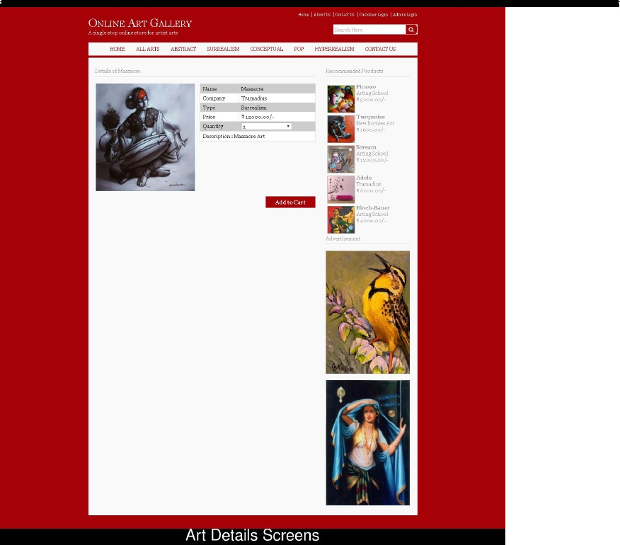

**4. ORDER DETAILS SCREEN**

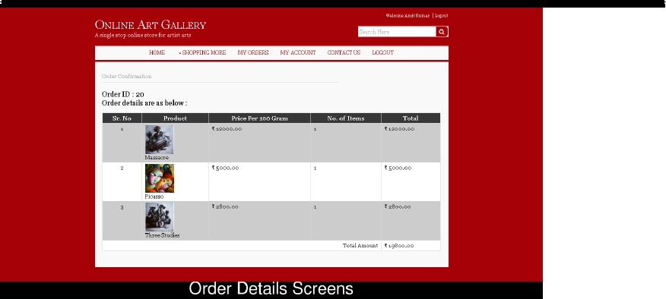

**5.CUSTOMER LOGIN SCREEN**

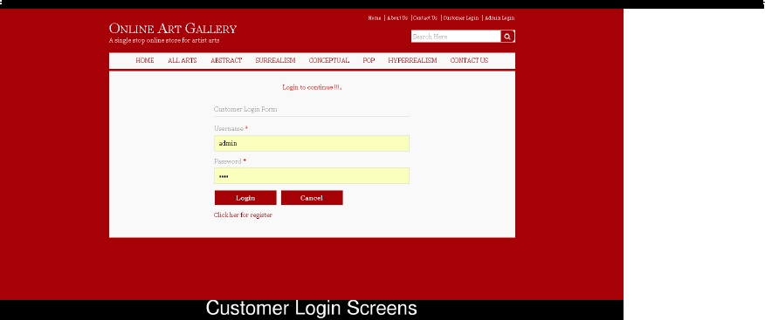

**CONCLUSION**

Our project is only a humble venture to satisfy the needs to manage their project work. Several user friendly coding have also adopted. This package shall prove to be a powerful package in satisfying all the requriments.The objective of the software planning is to provide a frame work that enables the manager to make responsible estimates made within a limited time frame.

**REFERENCES**

[WWW.GOOGLE.COM](http://WWW.GOOGLE.COM)

[WWW.FREEPROJECTZ.COM](http://WWW.FREEPROJECTZ.COM)

[WWW.WIKIPEDIA.COM](http://WWW.WIKIPEDIA.COM)